#### OOJ LAB PROGRAMS

# Program 1

import java.util.*;

public class quadratic {

public static void main (String args[]){

Scanner in= new Scanner(System.in);

double sq,disc,equal,root1=0,root2=0;

System.out.println("Enter coefficient of x^2: ");

double a=in.nextDouble();

System.out.println("Enter coefficient of x: ");

double b=in.nextDouble();

System.out.println("Enter constant c: ");

double c=in.nextDouble();

disc=(b*b)-(4.0*a*c);

sq=Math.sqrt(disc);

if(disc<0.0){

System.out.println("There are no real solutions");

}

else if(disc==0.0){

equal=-b/(2*a);

System.out.println("The roots are equal which is "+equal);

}

else{

root1=((-b)+sq)/(2.0*a);

root2=((-b)-sq)/(2.0*a);

System.out.println("The roots are "+root1+" and "+root2);

}

}

}

### OUTPUT

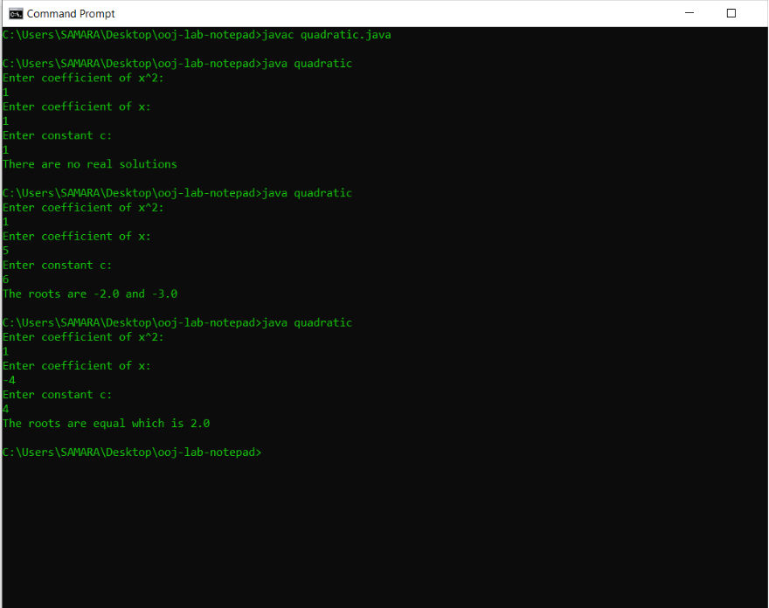

# Program 2

import java.util.*;

class student{

String name,usn;

double credits [] = new double[5];

double marks [] = new double[5];

double a[] = new double[5];

double total=0,tc=0,sgpa=0,tmc=0;

void getDetails(){

Scanner in = new Scanner(System.in);

System.out.println("Enter name and usn");

name=in.next();

usn=in.next();

for(int i=0;i<5;i++){

System.out.println("Enter marks and credits of subject "+(i+1));

marks[i]=in.nextDouble();

credits[i]=in.nextDouble();

}

}

void displayDetails(){

System.out.println("Name : "+name);

System.out.println("USN : "+usn);

for(int j=0;j<5;j++){

total+=marks[j];

}

System.out.println("Total marks : "+total);

}

void SGPA(){

for(int j=0;j<5;j++){

if(marks[j]>=90)

a[j]=10.0;

else if(marks[j]>=80 && (marks[j]<90))

a[j]=9.0;

else if(marks[j]>=70 && (marks[j]<80))

a[j]=8.0;

else if(marks[j]>=60 && (marks[j]<70))

a[j]=7.0;

else if(marks[j]>=50 && (marks[j]<60))

a[j]=6.0;

else

a[j]=0.0;

}

for(int n=0;n<5;n++){

tc+=credits[n];

tmc+=(credits[n]*a[n]);

}

sgpa=(tmc/tc);

System.out.println("SGPA : "+sgpa);

}

}

public class studentSgpa{

public static void main (String[] args) {

student s1=new student();

s1.getDetails();

s1.displayDetails();

s1.SGPA();

}

}

OUTPUT

### lab2-studentSgpa.png

# Program 3

import java.util.*;

class book{

public String booktitle,author;

public double price;

public int no_of_pages;

public book(){

author="chetan";

price=300;

no_of_pages=150;

}

public book(String booktitle,String author,double price,int no_of_pages){

this.booktitle=booktitle;

this.author=author;

this.price=price;

this.no_of_pages=no_of_pages;

}

public String toString(){

return(booktitle+" : "+author+" : "+price+" : "+no_of_pages);

}

void GetDetails(){

Scanner in = new Scanner(System.in);

System.out.println("Enter booktitle, author, no_of_pages and price");

booktitle=in.next();

author=in.next();

no_of_pages=in.nextInt();

price = in.nextDouble();

}

void SetDeatils(){

System.out.println("Book Title :"+booktitle);

System.out.println("Author :"+author);

System.out.println("No of pages:"+no_of_pages);

System.out.println("Price :"+price);

}

}

class KnowBook{

public static void main(String[] args) {

Scanner in = new Scanner(System.in);

int n;

System.out.println("Enter no of books");

n=in.nextInt();

book[] b = new book[n];

for(int i=0;i<n;i++){

b[i]=new book();

b[i].GetDetails();

}

System.out.println();

for(int i=0;i<n;i++){

System.out.println("Details of book "+(i+1));

System.out.println(b[i]);

System.out.println();

}

/*for(int i=0;i<n;i++){

b[i].SetDeatils();

System.out.println();

}*/

}

}

OUTPUT

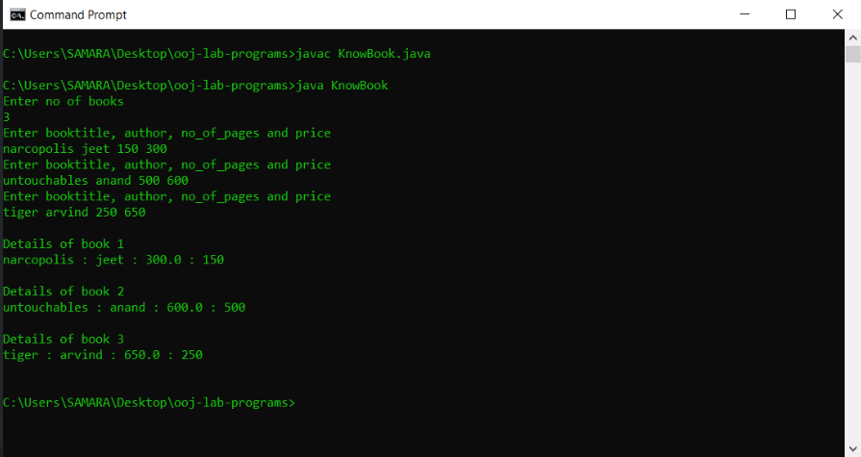

# Program 4

abstract class Shape{

int num1,num2;

void PrintArea(int a,int b) {

num1=a;

num2=b;

}

}

class Rectangle extends Shape{

void printArea(int num1,int num2) {

System.out.println("Area of rectangle = "+(num1*num2));

}

}

class Triangle extends Shape{

void printArea(int num1,int num2) {

System.out.println("Area of Triangle = "+((double)(num1*num2)/2));

}

}

class Circle extends Shape{

void printArea(int num1) {

System.out.println("Area of circle = "+(3.14*num1*num1));

}

}

public class Area {

public static void main(String[] args) {

Rectangle r = new Rectangle();

r.printArea(7,7);

Triangle t = new Triangle();

t.printArea(7,7);

Circle c = new Circle();

c.printArea(7);

}

}

OUTPUT

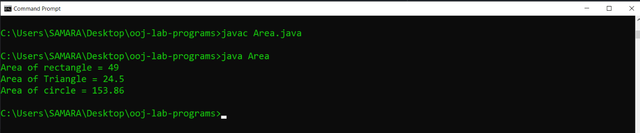

# Program 5

# 

import java.util.*;

class Account{

Scanner in=new Scanner(System.in);

String customer_name,type_of_account;

long account_number;

double balance=9876.5;

void Accept(){

System.out.println("Enter customer name ");

customer_name=in.nextLine();

System.out.println("Enter Account number");

account_number=in.nextLong();

}

void deposit(){

int dep;

System.out.println("Enter the amount to be deposited");

dep=in.nextInt();

balance+=dep;

System.out.println("Balance = "+balance);

}

void withdrawal(){

int witdra;

System.out.println("Enter the amount you want to withdraw");

witdra=in.nextInt();

balance-=witdra;

System.out.println("Balance = "+balance);

}

}

class CurrAct extends Account{

void penalty(){

if(balance<1000){ //Assuming minimum balance to be 1000

balance-=100;

System.out.println("100 penalty for maintainin less than minimum balance");

System.out.println("Balance = "+balance);

}

}

}

class SavAct extends Account{

void interest(){

double i;

i=balance*0.02; //Assuming interest rate to be 2%

balance+=i;

System.out.println("Interest = "+i);

System.out.println("Total Balance = "+balance);

}

}

class Bank{

public static void main(String[] args) {

Scanner in=new Scanner(System.in);

CurrAct c= new CurrAct();

SavAct s= new SavAct();

System.out.println("Enter your choice\n1. Savings Account \n2.Current Account");

int choice=in.nextInt();

if(choice==2){

c.Accept();

System.out.println("Enter your choice\n1. Deposit\n2. Withdraw");

int n=in.nextInt();

switch (n) {

case 1:{

c.deposit();

break;

}

case 2:{

c.withdrawal();

c.penalty();

break;

}

default:System.out.println("Wrong choice!");

}

}

if(choice==1){

s.Accept();

System.out.println("Enter your choice\n1. Deposit\n2. Withdraw");

int n=in.nextInt();

switch (n) {

case 1:{

s.deposit();

s.interest();

break;

}

case 2:{

s.withdrawal();

break;

}

default:System.out.println("Wrong choice!");

}

}

}

}

OUTPUT

